**[Microcontroller AT89C51](http://www.engineersgarage.com/microcontroller-at89c51" \o "Microcontroller AT89C51)**

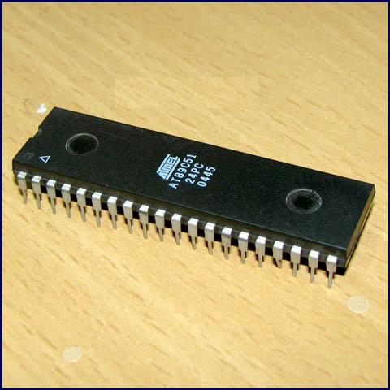

**Pin Diagram:**

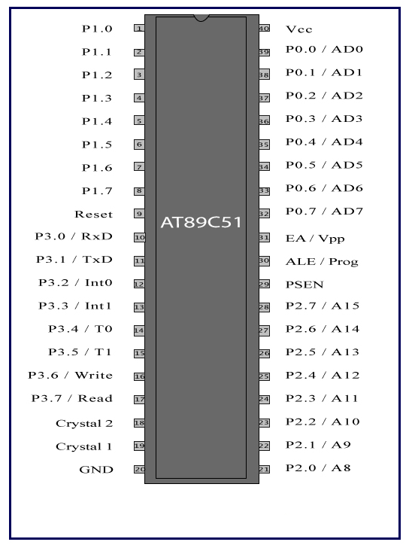

**Pin Description:**

|  |  |  |  |  |
| --- | --- | --- | --- | --- |
| **Pin No** | **Function** | | | **Name** |
| 1 | 8 bit input/output port (P1) pins | | | P1.0 |
| 2 | P1.1 |
| 3 | P1.2 |
| 4 | P1.3 |
| 5 | P1.4 |
| 6 | P1.5 |
| 7 | P1.6 |
| 8 | P1.7 |
| 9 | Reset pin; Active high | | | Reset |
| 10 | Input (receiver) for serial communication | RxD | 8 bit input/output port (P3) pins | P3.0 |
| 11 | Output (transmitter) for serial communication | TxD | P3.1 |
| 12 | External interrupt 1 | Int0 | P3.2 |
| 13 | External interrupt 2 | Int1 | P3.3 |
| 14 | Timer1 external input | T0 | P3.4 |
| 15 | Timer2 external input | T1 | P3.5 |
| 16 | Write to external data memory | Write | P3.6 |
| 17 | Read from external data memory | Read | P3.7 |
| 18 | Quartz crystal oscillator (up to 24 MHz) | | | Crystal 2 |
| 19 | Crystal 1 |
| 20 | Ground (0V) | | | Ground |
| 21 | 8 bit input/output port (P2) pins  /  High-order address bits when interfacing with external memory | | | P2.0/ A8 |
| 22 | P2.1/ A9 |
| 23 | P2.2/ A10 |
| 24 | P2.3/ A11 |
| 25 | P2.4/ A12 |
| 26 | P2.5/ A13 |
| 27 | P2.6/ A14 |
| 28 | P2.7/ A15 |
| 29 | Program store enable; Read from external program memory | | | PSEN |
| 30 | Address Latch Enable | | | ALE |
| Program pulse input during Flash programming | | | Prog |
| 31 | External Access Enable;  Vcc for internal program executions | | | EA |
| Programming enable voltage; 12V (during Flash programming) | | | Vpp |
| 32 | 8 bit input/output port (P0) pins    Low-order address bits when interfacing with external memory | | | P0.7/ AD7 |
| 33 | P0.6/ AD6 |
| 34 | P0.5/ AD5 |
| 35 | P0.4/ AD4 |
| 36 | P0.3/ AD3 |
| 37 | P0.2/ AD2 |
| 38 | P0.1/ AD1 |
| 39 | P0.0/ AD0 |
| 40 | Supply voltage; 5V (up to 6.6V) | | | Vcc |